Physics 1 Unit 3 – Forces Name: ___________________________

IB 2.2 Forces - Multibody Systems with friction

1. Three masses (2.00 kg, 3.00 kg and 5.00 kg) are connected by cords and pulled to the right by a 16.0 N force that is parallel to the surface the blocks are moving at a constant speed. Determine the coefficient of kinetic friction between the blocks and the surface and the tension in each cord if the masses are ordered a) smallest to largest with the largest on the right, or b) largest to smallest with the smallest on the right.
2. A 1.50 kg cat tries to leap onto a table with a table cloth and has an epic failure missing the table, but snagging the table cloth with her claws. If the coefficient of kinetic friction between the table cloth and the table is 0.13 and there is a total of 2.50 kg of items on the table, determine the acceleration of the cat as she falls, hanging onto the table cloth.
3. When the three blocks as shown below are released from rest, they accelerate with a magnitude of 0.500 m/s2. Block 1 has mass M, block 2 has mass 2M and block 3 has mass 3M. What is the coefficient of kinetic friction between block 2 and the table? b) What is M? c) What are the tensions in the two cords, T1 and T2?

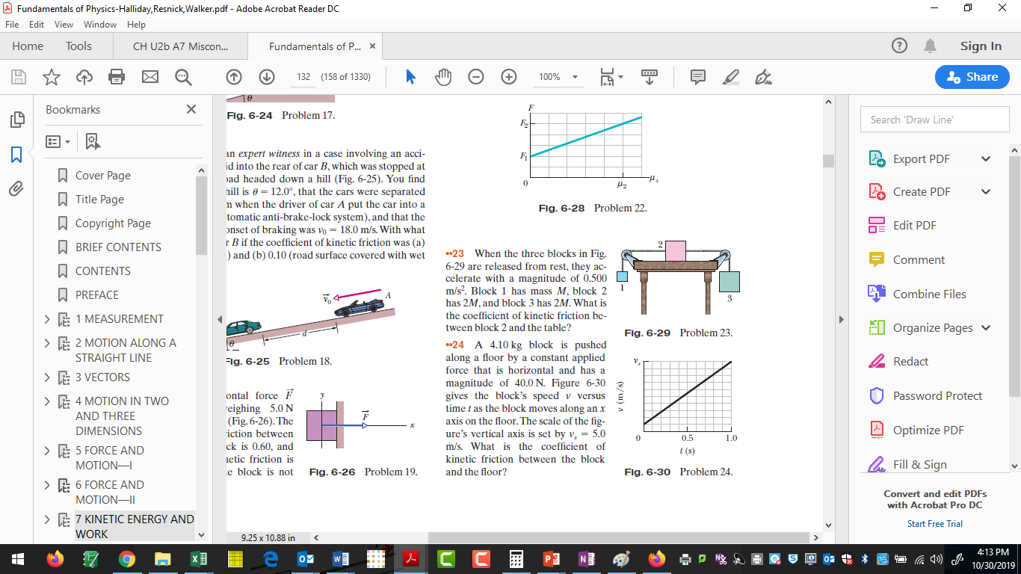

1. Block B weighs 711 N. The coefficient of static friction between block B and the table is 0.25. The angle is 30. Assume that the cord between B and the knot is horizontal. a) Find the maximum weight of block A for which the system will be stationary. b) If the system with the maximum weight block is nudged, with what acceleration does it move if the coefficient of dynamic friction is 0.18?

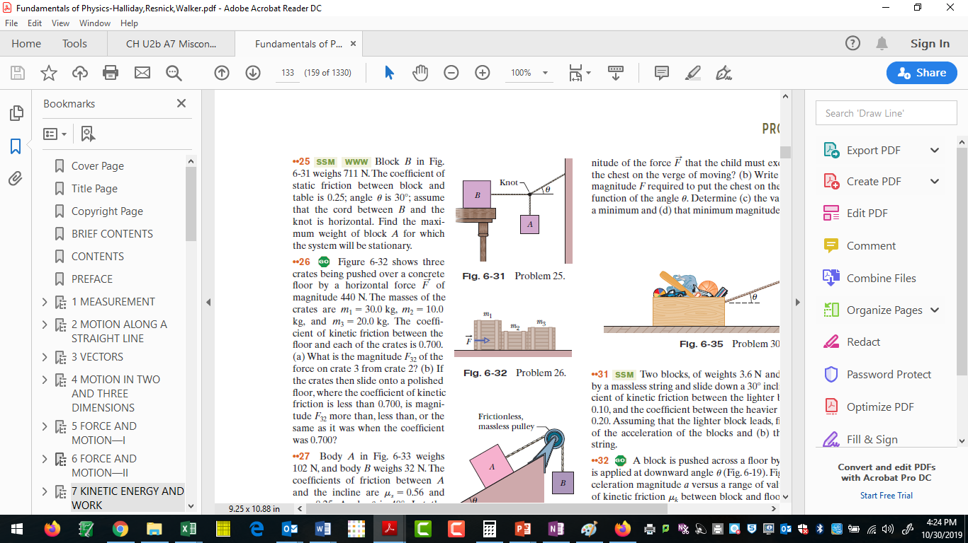

1. Block A has a mass of 3.50 kg and the incline angle is 40. The incline is frictionless and the pulley is frictionless and massless. What is the mass of block B and the tension in the cord when block A is a) at rest, b) moving at a constant velocity up the incline and c) moving at a constant velocity down the incline.

